1. Find skewness of “Weight of case” and “Age”. Give interpretation.

|  |  |  |  |
| --- | --- | --- | --- |
| **Statistics** | | | |
|  | | Age in Years | Weight of case in kg |
| N | Valid | 70 | 70 |
| Missing | 0 | 0 |
| Skewness | | .000 | .362 |
| Std. Error of Skewness | | .287 | .287 |

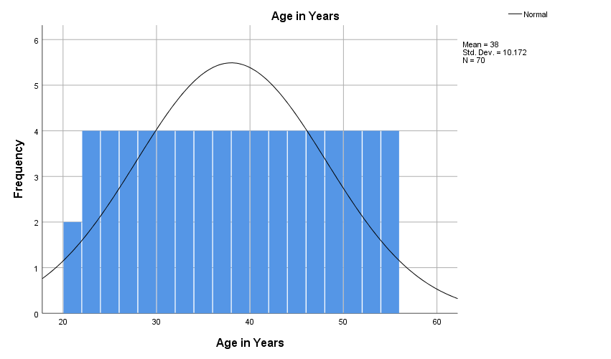

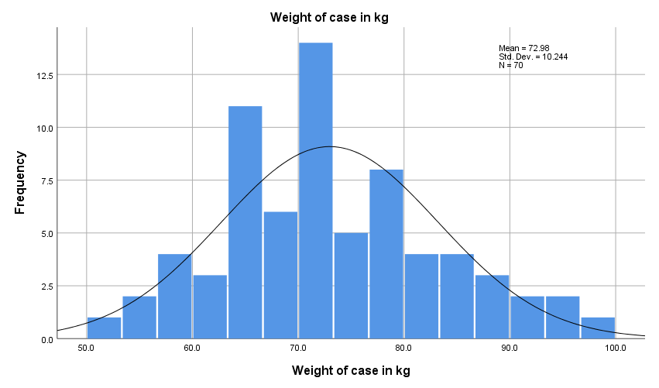

Age is normal distribution. Because skewness is 0.

Weight of case is positively skewed distribution or skewed to the right. Because skewness > 0.

2. Evaluate normality of same variables.

|  |  |  |  |  |  |  |
| --- | --- | --- | --- | --- | --- | --- |
| **Case Processing Summary** | | | | | | |
|  | Cases | | | | | |
| Valid | | Missing | | Total | |
| N | Percent | N | Percent | N | Percent |
| Age in Years | 70 | 100.0% | 0 | 0.0% | 70 | 100.0% |
| Weight of case in kg | 70 | 100.0% | 0 | 0.0% | 70 | 100.0% |

|  |  |  |  |  |
| --- | --- | --- | --- | --- |
| **Descriptives** | | | | |
|  | | | Statistic | Std. Error |
| Age in Years | Mean | | 38.00 | 1.216 |
| 95% Confidence Interval for Mean | Lower Bound | 35.57 |  |
| Upper Bound | 40.43 |  |
| 5% Trimmed Mean | | 38.00 |  |
| Median | | 38.00 |  |
| Variance | | 103.478 |  |
| Std. Deviation | | 10.172 |  |
| Minimum | | 21 |  |
| Maximum | | 55 |  |
| Range | | 34 |  |
| Interquartile Range | | 18 |  |
| Skewness | | .000 | .287 |
| Kurtosis | | -1.202 | .566 |
| Weight of case in kg | Mean | | 72.976 | 1.2244 |
| 95% Confidence Interval for Mean | Lower Bound | 70.533 |  |
| Upper Bound | 75.418 |  |
| 5% Trimmed Mean | | 72.750 |  |
| Median | | 71.750 |  |
| Variance | | 104.933 |  |
| Std. Deviation | | 10.2437 |  |
| Minimum | | 53.2 |  |
| Maximum | | 97.6 |  |
| Range | | 44.4 |  |
| Interquartile Range | | 14.8 |  |
| Skewness | | .362 | .287 |
| Kurtosis | | -.286 | .566 |

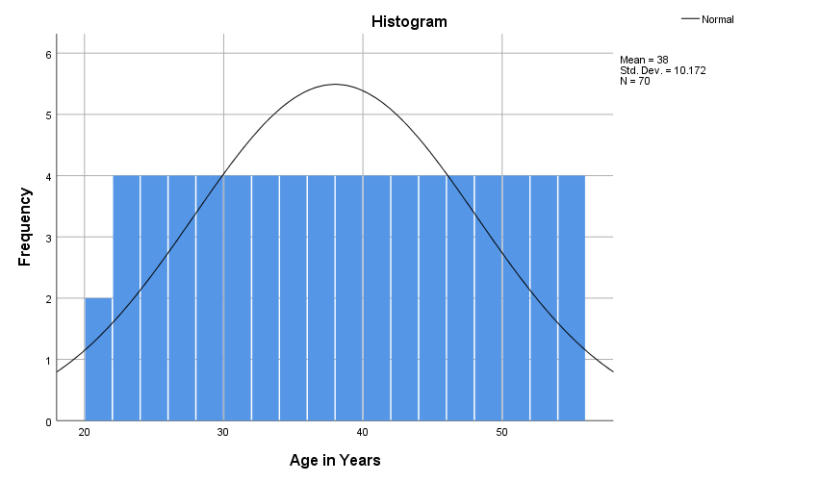

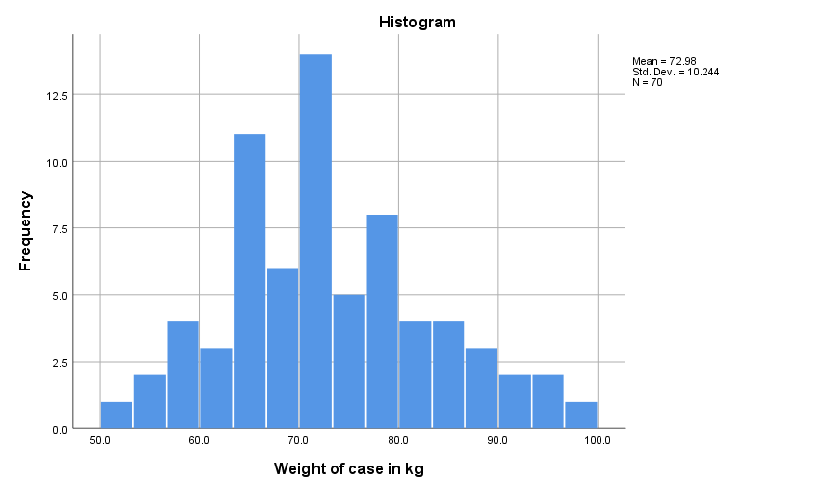

|  |  |  |  |  |  |  |
| --- | --- | --- | --- | --- | --- | --- |
| **Tests of Normality** | | | | | | |
|  | Kolmogorov-Smirnova | | | Shapiro-Wilk | | |
| Statistic | df | Sig. | Statistic | df | Sig. |
| Age in Years | .070 | 70 | .200* | .954 | 70 | .011 |
| Weight of case in kg | .083 | 70 | .200* | .980 | 70 | .335 |
| *. This is a lower bound of the true significance. | | | | | | |
| 1. Lilliefors Significance Correction   Both variables are normally distributed. Because Significance (0.011 and 0.335) is greater than 0.05. | | | | | | |

3. Apply empirical rule to height of case if the variable is normally distributed.

|  |  |  |
| --- | --- | --- |
| **Statistics** | | |
| Height of case in cm | | |
| N | Valid | 70 |
| Missing | 0 |
| Mean | | 170.106 |
| Std. Deviation | | 10.3985 |
| Minimum | | 150.7 |
| Maximum | | 192.3 |

Mean +/- 1 Std. Deviation = 170.11 +/- 10.40 = 159.71/180.51

It means 68% (70*68%=47.6) of values are between 159.71 and 180.51

Mean +/- 2 Std. Deviation = 170.11 +/- 2*10.40 = 149.31/191.1

It means 95.4% (70*94=95.94%=67.15) of values are between 149.31 and 191.1

Mean +/- 3 Std. Deviation = 170.11 +/- 3*10.40 = 138.91/201.31

It means 99.7% (70*99.7%=69.79) of values are between 138.91 and 201.31

4. Assume “Height of case” and “Weight of case” are normally distributed. Compute following probabilities

|  |  |  |  |
| --- | --- | --- | --- |
| **Statistics** | | | |
|  | | Height of case in cm | Weight of case in kg |
| N | Valid | 70 | 70 |
| Missing | 0 | 0 |
| Mean | | 170.106 | 72.976 |
| Std. Deviation | | 10.3985 | 10.2437 |

1. What is the probability of a patient has height more than 1.70 cm?

Mean = 170.11

Std. Deviation = 10.40

Z = (170-170.11)/10.40 = -0.01

In table -0.01 shows 0.5040. It means the probability of a patient has height more than 1.70 cm is 1-0.504=0.496 (49.6%)

1. What is the probability of a patient has weight between 65 and 75 kg?

Mean = 72.98

Std. Deviation = 10.24

Z(1) = (75-72.98)/10.24 = 0.20

Z(2) = (65-72.98)/10.24 = -0.78

In table 0.20 shows 0.5793 and -0.78 shows 0.2177. It means the probability of a patient has weight between 65 and 75 kg is 0.5793 – 0.2177 = 0.3616 (36.16%)

1. What is the probability of a patient has height less than 1.50 cm?

Mean = 170.11

Std. Deviation = 10.40

Z = (150-170.11)/10.24 = -1.96

In table -1.96 shows 0.0250. It means the probability of a patient has height less than 1.50 cm is 2.5%

5. You have given a sample medical data. Find confidence interval for “Height of case” and “Weight of case” of population mean.

|  |  |  |  |  |
| --- | --- | --- | --- | --- |
| **Descriptives** | | | | |
|  | | | Statistic | Std. Error |
| Age in Years | Mean | | 38.00 | 1.216 |
| **95% Confidence Interval for Mean** | **Lower Bound** | **35.57** |  |
| **Upper Bound** | **40.43** |  |
| 5% Trimmed Mean | | 38.00 |  |
| Median | | 38.00 |  |
| Variance | | 103.478 |  |
| Std. Deviation | | 10.172 |  |
| Minimum | | 21 |  |
| Maximum | | 55 |  |
| Range | | 34 |  |
| Interquartile Range | | 18 |  |
| Skewness | | .000 | .287 |
| Kurtosis | | -1.202 | .566 |
| Weight of case in kg | Mean | | 72.976 | 1.2244 |
| **95% Confidence Interval for Mean** | **Lower Bound** | **70.533** |  |
| **Upper Bound** | **75.418** |  |
| 5% Trimmed Mean | | 72.750 |  |
| Median | | 71.750 |  |
| Variance | | 104.933 |  |
| Std. Deviation | | 10.2437 |  |
| Minimum | | 53.2 |  |
| Maximum | | 97.6 |  |
| Range | | 44.4 |  |
| Interquartile Range | | 14.8 |  |
| Skewness | | .362 | .287 |
| Kurtosis | | -.286 | .566 |

6. Using the data set turnover_babushkin.csv Find relationship between following variables.

a. Novator and Anxiety

|  |  |  |  |
| --- | --- | --- | --- |
| **Correlations** | | | |
|  | | anxiety | Novator |
| anxiety | Pearson Correlation | 1 | .240** |
| Sig. (2-tailed) |  | .000 |
| N | 1129 | 1129 |
| novator | Pearson Correlation | .240** | 1 |
| Sig. (2-tailed) | .000 |  |
| N | 1129 | 1129 |
| **. Correlation is significant at the 0.01 level (2-tailed). | | | |

Sig. is less than 0.05 and Correlation coefficient is less than 0.30. There is significant weak correlation between variables.

1. Self-control and Novator

|  |  |  |  |
| --- | --- | --- | --- |
| **Correlations** | | | |
|  | | novator | selfcontrol |
| novator | Pearson Correlation | 1 | -.569** |
| Sig. (2-tailed) |  | .000 |
| N | 1129 | 1129 |
| selfcontrol | Pearson Correlation | -.569** | 1 |
| Sig. (2-tailed) | .000 |  |
| N | 1129 | 1129 |
| **. Correlation is significant at the 0.01 level (2-tailed). | | | |

Sig. is less than 0.05 and Correlation coefficient is less than 0.30. There is significant weak correlation between variables. Correlation coefficient is negative. We put it into module and it will be .569. This is moderate correlation and it is inverse.

1. Hire_source and left company

|  |  |  |  |
| --- | --- | --- | --- |
| **Symmetric Measures** | | | |
|  | | Value | Approximate Significance |
| Nominal by Nominal | Phi | .184 | .000 |
| Cramer's V | .184 | .000 |
| N of Valid Cases | | 1129 |  |

Sig. is less than 0.05. These is significant relationship between 2 variables. Value is greater than 0.15. The strength of association between 2 variables is strong.

1. Profession and left company

|  |  |  |  |
| --- | --- | --- | --- |
| **Symmetric Measures** | | | |
|  | | Value | Approximate Significance |
| Nominal by Nominal | Phi | .199 | .000 |
| Cramer's V | .199 | .000 |
| N of Valid Cases | | 1129 |  |

Sig. is less than 0.05. These is significant relationship between 2 variables. Value is greater than 0.15. The strength of association between 2 variables is strong.

1. Industry and left company

|  |  |  |  |
| --- | --- | --- | --- |
| **Symmetric Measures** | | | |
|  | | Value | Approximate Significance |
| Nominal by Nominal | Phi | .239 | .000 |
| Cramer's V | .239 | .000 |
| N of Valid Cases | | 1129 |  |

Sig. is less than 0.05. These is significant relationship between 2 variables. Value is greater than 0.15. The strength of association between 2 variables is strong.

1. Tenure and Age

|  |
| --- |
|  |

Sig. is less than 0.05 and Correlation coefficient is greater than 0.70. There is significant strong correlation between variables.